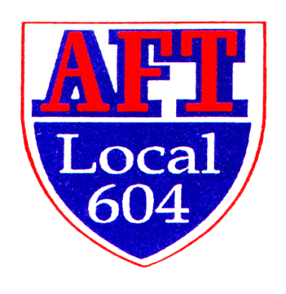
Jacqueline B. Vaughn Rubric
Paul O. Johnson Rubric
Awarded by AFT Local 604

Applicant: _____________________________________

Judge: _____________________________________

Categories | Maximum Score | Your Score
Essay (see rubric below for scoring) | 50
Transcript | 20
School-related Activities—Check all; explain  ___ Academics  ___ Clubs  ___ Sports  ___ Arts  ___ Leadership role in activities | 15
Community Involvement—Check all; explain  ___ Work  ___ Volunteer  ___ Spiritual  ___ Travel teams  ___ Organizations, like Boy/Girl Scouts  ___ Other | 10
Recommendation letter from current teacher, administrator, or counselor | 5
 | Total Score

Rubric
Rubric Components |  |  |  |  | Score
Focus/Main Point  (20 Points) | The essay poorly addresses the topic and includes irrelevant ideas  14 points or less | The essay is focused on topic and includes few loosely related ideas  15-16 points | The essay is focused on the topic and includes relevant ideas  17-18 points | The essay is focused, purposeful, and reflects clear insight and ideas  19-20 points
Organization & Format (Paragraphs, Transitions)  (15 Points) | Little or no organization of ideas to build an argument; lacks a thesis, conclusion, or both  9 points or less | Some organization of ideas to build an argument, but has a weak thesis and conclusion  10-11 points | Organizes ideas to build a strong thesis and conclusion  12-13 points | Effectively organizes ideas to build a logical, controlling thesis and conclusion  14-15 points
Language, Use, Style & Conventions  (Sentence structure, word choice, grammar, spelling, punctuation  (10 Points) | Little or no use of elements of style  Many errors in grammar, spelling, and punctuation  4 points or less | Some use of elements of style  Contains frequent errors in grammar, spelling, and punctuation  5-6 points | Appropriate use of elements of style  Uses correct grammar, spelling, and punctuation with few errors  7-8 points | Effective and creative use of elements of style to enhance meaning  Uses correct grammar, spelling, punctuation limited errors  9-10 points
Originality  (Expression of the theme in a creative way)  (5 Points) | No experimentation nor enhancement of concepts  No adherence to the theme  2 points or less | Very little experimentation to enhance concepts  Does not exhibit creativity  3 points | Sufficient experimentation with language and usage to enhance concepts  Applies basic creative skills to relay ideas  4 points | Distinctive experimentation with language and usage to enhance concepts  Applies higher order thinking and creative skills to relay complex ideas  5 points

