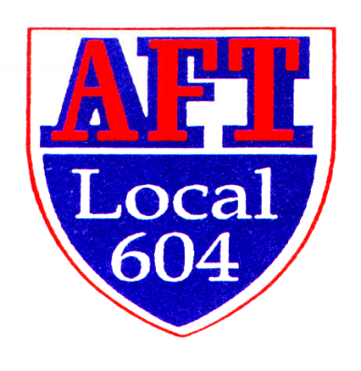
Richard Manley Scholarship Application
For Current Professional Educators
Awarded by AFT Local 604

The Richard Manley Scholarship is awarded in honor of a man who built AFT Local 604 into the position of respect it holds today not only in Illinois, but also the American Federation of Teachers. Anyone who knew or met Dick realized his passion for AFT Local 604 and our members. Dick served as president of AFT Local 604 when it merged with Local 1291 from April of 1976 until his retirement in January of 2018. Before that, he was president of Lockport Federation of Teachers Local 1291 starting in 1969. He began his teaching career at Serena High School before moving to Lockport Township High School, where he taught physics for 34 years. During his leadership, AFT Local 604 became the second largest local in the IFT and the 14th largest in the AFT with over 11,000 members and 75 councils in 10 counties.

AFT Local 604 is offering at least one scholarship up to $2,000. The initial scholarship application is due December 16, 2021, and those awarded will be announced at the February Senate meeting. Applicants must be a current licensed, practicing educator and a member in good standing in AFT Local 604. He/she must be pursuing a certificate, endorsement in an education-related field or working on a district- approved master’s program.

Rules and Requirements:
- Completed application must be in AFT Local 604 office by noon on or before Dec. 15th
- Applicant must be a tenured professional educator
- All requested information must be included at one time with the application
- The essay should not exceed 600 words
- Letter of Recommendation from a Union officer
- Typed/printed copy of the Program Course Requirements with list of all required courses and courses completed

Essay: In no more than 600 words, select one of the following topics.
- Explain your motivation in pursuing this academic study and how it will impact your work with students and the district.

- Explain your involvement in your Union and how being a Union member has impacted you.

Richard Manley Scholarship Application—page 2

Date ____________

First Name _______________________ Last Name _________________________________

Mailing Address ________________________________________________________________

City, State, Zip _________________________________________________________________

Personal E-mail ___________________ Cell Phone ________________________________

AFT Local 604 Council Name _____________________________________________________

Your Council President’s Name ____________________________________________________

In what district are you employed ________________________ How many years ____________

Current Position ________________________________________________________________

Does your district offer tuition reimbursement _________________________________________

If yes, have your applied/received any monies _______________; Amount __________________

Cost per credit hour ________________ Number of hours in this application _____________

Other applicable expenses ________________________________________________________

What university/college would/are you attending_______________________________________

What is the program’s title ________________________________________________________

Explain the program you are pursing and how it will enhance your teaching _________________

______________________________________________________________________________

AFT Local 604
1520 N. Rock Run Drive #1
Crest Hill, IL 60403-3232
815-725-0402

